Lab 21

Preparation

1.

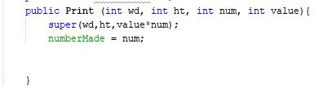

2. Art class

3.

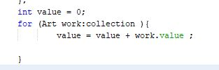

4. In C class there is a error in System.out.println(“s is”+super.s);

5.

6. For swing.\* - jpannel,jframe

For swt.\*- graghics , color

For event.\* -actionListener

For util.\* - random

7.

Every Java class is a subclass of Object class. ... Basically, since every class extends Object , calling toString calls the Object implementation, unless the class provides it's own implementation. The default method returns a String containing some information about the class.